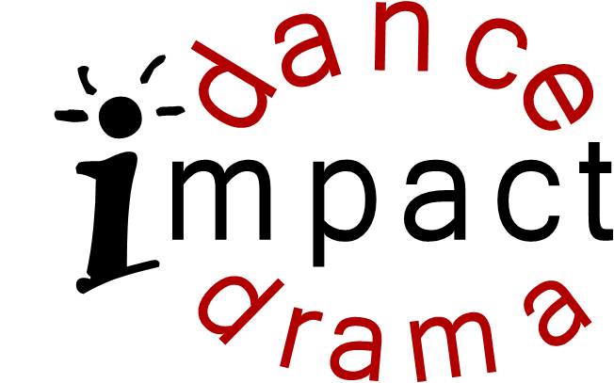

Children’s Journey Preschool

Pre-Ballet/Creative Movement

Spring 2021

Ages 3-5
Wednesdays 2:30-3:15 PM
January 27th – March 31st
No class February 17th or March 17th

Fee $90
Note: Dance class runs all year. If your child wishes to continue into the summer, there will be another payment due before the next session begins.

At this early stage, young dancers learn basic ballet technique using fun and imaginative stretching and movement exercises. This gentle introduction to classical ballet will also aid in developing coordination, spatial awareness and fine and gross motor skills. Children will delight in this class that encourages imagination, creativity as well as group interaction and working together! Impact instructors pride themselves on teaching fun, new and innovative classes while providing the structure and discipline required to learn proper dance technique.

Class Attire:

Girls: Black or pink leotard, pink tights Pink ballet shoes.
Boys: Black shorts or pants and white T-shirt Black ballet shoes

Register:

Name ____________________________________ Birth Date ______________________ Age _____ Gender _____

Teacher/Classroom at CJP____________________________________

Parent or Guardian Name(s)___________________________________ Email ______________________________

Address ______________________________________________________________________________________

Phone ____________________________________ Phone 2 ____________________________________________

Payment may be made online with your credit/debit card at www.impactdanceanddrama.com. Checks may be made payable to Impact and returned to the school office. Payment must be received in order to secure a class space.

Classes are held on the Children’s Journey Preschool Campus.

I consent to the release of Impact Dance and Drama, LLC, their officers, agents, employees and staff from any and all liabilities. Tuition may not be prorated for missed classes or days. I understand Impact may combine, cancel or provide substitutes for any class at their discretion. By signing up for and paying for this class, I am giving permission for Children’s Journey Preschool to allow Impact Instructors to take my child to class. Classes missed or cancelled due to school closures related to but not limited to Covid19 or influenza will not be refunded and will be made up via our online portal. I also understand that as part of my child’s participation in Impact programs, photos and videos may occasionally be taken during classes to use in certain media outlets. (If you do not wish your child to appear in any of these pictures, please just let us know via email.) I understand tuition is nonrefundable. Form must be signed for the child to participate.

Parent/Guardian Date

www.impactdanceanddrama.com 407.984.6902 impactdanceanddrama@gmail.com

